**CS544**

**Enterprise Architecture Final**

## Exam 2 Example

Name___Abdelrady Tantawy___________________________

Student ID __986834__________________________________

**NOTE: This material is private and confidential. It is the property of MUM and is not to be disseminated.**

1. [15 Points] The following screen displays the member entry screen. Annotate The Member & User Credentials domain objects to reflect the Validation requirements. The provided Member Controller also needs to be annotated. Also the controller methods need to be completed as necessary [ including validation support].

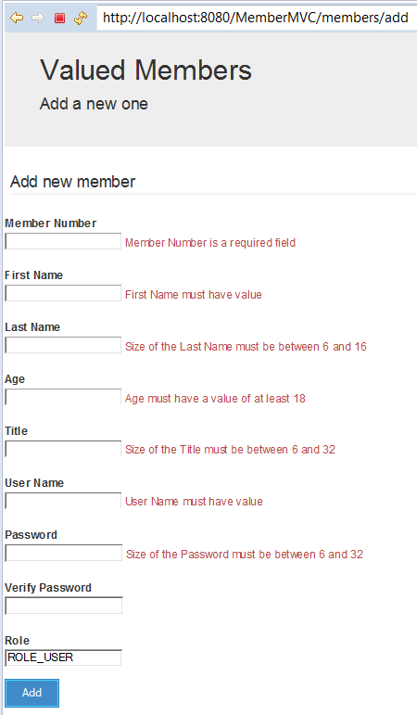

**Here is the relevant part of the Member Domain Class:**

@Entity

**public** **class** Member {

@Id

@GeneratedValue(strategy=GenerationType.***AUTO***)

**private** **long** id;

@NotEmpty()

@Column(length = 16)

**private** String firstName;

@NotEmpty()

@Size(min = 6, max = 16, message = "{size}")

@Column(length = 16)

**private** String lastName;

@Min(value = 18, message = "{minNumber}")

**private** Integer age;

@Size(min = 6, max = 32, message = "{size}")

@Column(length = 32)

**private** String title;

@NotNull

**private** Integer memberNumber;

@OneToOne(fetch=FetchType.***EAGER***, cascade = CascadeType.***ALL***)

@JoinColumn(name="member_id")

UserCredentials userCredentials;

**Here is the UserCredentials:**

@Entity(name = "Authentication")

**public** **class** UserCredentials {

@Id

@Column(name = "USER", nullable = **false**, unique = **true**, length = 127)

@NotEmpty()

String userName;

@Size(min = 6, max = 32, message = "{size}")

@Column(name = "PASSWORD", nullable = **false**, length = 32)

String password;

@Column( nullable = **false**, length = 32)

String verifyPassword;

Boolean enabled;

@OneToOne(mappedBy="userCredentials", cascade = {CascadeType.***PERSIST***, CascadeType.***MERGE***})

**private** User user;

**ErrorMessage.properties**

**NotNull= {0} is a required field**

**NotEmpty= {0} must have a value**

**size = Size of the {0} must be between {2} and {1}**

**minNumber = {0} must have a value of at least {1}**

**firstName= First Name**

**lastName= Last Name**

**userName= User Name**

**memberNumber= Member Number**

**MemberController.java**

@Controller

**public** **class** MemberController {

@Autowired

**private** MemberService memberService;

**public** String getAddNewMemberForm(@ModelAttribute("newMember") Member newMember) {

**return** "addMember";

}

**public** String processAddNewMemberForm(@Valid @ModelAttribute("newMember") Member memberToBeAdded, BindingResult result){

**if (result.hasErrors()) {**

**return "addMember";**

**}**

memberService.save(memberToBeAdded);

**return** "redirect:/members";

}